Publix Transportation Business Plan Outline
Briana Richardson
Brandman University
MGTU 410

Executive Summary
Publix is an already operational grocery supermarket operating in many different cities within the U.S. The organization is under a plan to improve their quality service provision by introducing transportation services to their business venture to cater to the elderly and the disabled in Jacksonville, Florida. The organization expects to gain a competitive edge over its competitors considering that Jacksonville has a high population of elderly and disabled. Putting into consideration the COVID-19 pandemic, transport services to elderly and disabled will help to keep them safe from the pandemic. The company expects to get sufficient labor force needed, considering that many of the population lost their employment opportunities due to this pandemic. The financial state of the company puts them in a good position to undertake the plan as they have very low debts and the company makes high profits, being the top ranked for provision of quality service.

COMPANY DESCRIPTION

Type of business and legal structure
Publix super market is commonly known as Publix. It is an employee-owned supermarket which is a private company that is solely owned by present and past employees and members of the Jenkins Family (https; publix.com) unlike Publix companies which are owned by public. Publix is a retail industry in that it sells consumer goods and services to customers through multiple channels of distributions. The successful nature of Publix can be attributed to it being employee owned, where it has turned servicemen such as cashiers, baggers and bankers into its largest shareholders (Publix Grocery Store, 2017).
Publix core competences are their abilities to develop new products and services which are consumer friendly thus providing a wide variety of markets. Offering quality products and services that meets customers’ preferences is one of Publix’s core competency. They develop new products and services as per their customers need and they emphasize more on quality of their goods and services. In addition customer service is one of their core competencies, this is evident by introduction of transport service to their business making their business venture more accessible by customers in times of needs. Publix is widely praised for offering high quality goods and services at low costs. By being consumer sensitive and doing sufficient consumer research they gain competitive edge in the market as they are of the new trends in market and are well alert of any possible threat to the company giving them advantage over their competitors.
Publix operates throughout the southeastern United States with locations in Florida, Georgia, South Carolina, Tennessee, North Carolina and Virginia (facts & figures 2018). Publix has its headquarters located at Lakeland, Florida. Publix had employed a total of 193,000 people as at. 2019. These people are employed in its retails, cooking schools, corporate Offices, distribution centers and manufacturing facilities are targeted towards a sole goal of meeting customers’ satisfaction.
Mission and Vision Statement & Innovation Description
Research by the National Aging and Disability Transport Centre indicates that transportation of both elderly and disabled has been a significant challenge in US. Research shows that eighty percent disabled and forty percent elderly do not drive thus becomes difficult to engage in short journeys and activities since they don’t acquire transport services in their areas of interest (Shaver,2018). Given that the mobility, issue constitutes the most significant challenge for the elderly in the U.S. in the years 2008-2012. The 2012 U.S. census reported that nearly 40% of the elderly above 65 have at least one disability and two-thirds of this population has walking or climbing challenges (U.S census 2012).
In order to solve the gap that has been thriving of interdependency of the disabled and the elderly on families and friends. Publix innovation idea on accessibility service on transport provision has ensured transportation on this group of people hence promoting a symbiotic relationship within the community since they can now live and access services independently. This idea solves this problem since the company mission ensures accessibility and quality services are addressed to all the customers.
Publix has been healthy and financially stable due to financial planning under the company’s vision and mission operations, this includes the all the financial flow and allocations that the company undergoes in operations of resources in running the company. Through the feasibility study the financial records which indicates that the company profitability has been stable over a period of time. The stability and the healthiness of the company has been achieved as result of full support of the innovation venture by the revenue and profit accrued. The company saw its revenue sales rise from $36 billion in 2018 to $38 billion in 2019. The company made a profit of $3 billion in 2019, which is a 26% increase in profit from the $2.4 billion profit they made in 2018 (Bouffard, 2020).
In accordance to the mission statement to be a premier quality food retailer in the world they are dedicated in ensuring customer services and community integration and involvement and being a great place to work and shop. The company having a unique philosophy of giving best quality service and treatment has made it to be ranked as at first position in terms of customer service.
Availability of demand of the services by the elderly and aged despite that the research indicates that it’s difficult to find (Gleckman, 2019) this is shown by less information available on the service providers and lack of independent sources to provide this services .with the of customized local information Publix is in a position to give a solution to the problem hence the company should take advantage of the available opportunity to innovate and invest.

Industry analysis and trends
History of Publix supermarkets incorporate dates back to 1930 when it was founded by George W Jenkins. Publix is a private corporation owned by Jenkins family and by its employees (facts & figures Publix supermarket, 2018). Its headquarters are situated at Lake Land Florida. In its first year of operation the store earned $500 during the Great Depression. By 1935, Jenkins owned five stores. By 1940 there were a total of 18 Publix operating stores. In 1950 there was a chain sale of $12.1 million from the 22 Publix supermarkets. The state of Florida contributed greatly to the growth of Publix as it became the fastest growing state in the country. In 1965 Publix had 114 stores and by 1970 it had 157 stores. The company reached $ 2 billion in sales and it had 234 stores and 26,000 employees by 1979. Publix’s investments in technology and advertisement contributed highly to its expansion. In 1995 even after many legal woes in the previous years, Publix made it into the fortune 500 list (back in time: Publix in the 90s, the Publix checkout 2019). Today Publix has 1252 location with 197000 employees (facts & figures: Publix supermarket 2018). Publix is said to operate throughout South Eastern United States with locations with 813 locations in Florida, 189 in Georgia, 78 in Alabama, 64 in South Carolina, 46 in Tennessee, 46 in North Carolina and 16 in Virginia (facts &figure : Publix supermarket 2018). Publix is one of the largest United States Grocery chain stores and also the largest employee-owned company in the U.S.
The key players in the Publix industry are their employees who are also their main stakeholders. They have an exclusive option to invest in the company. Company store is available only to current employees on board of directors. The employee stock ownership plan (ESOP) prohibits any transfer of value before the stakeholder fast offers the common stock to the company.
To focus on competitive advantage analysis Publix Company has a competitive advantage over its competitors by focus on customers’ research to understand the trends in the market. To start with the quality of service, Publix Company having positioned as top quality service providers that have gained trust in quality provision. This makes them the best option for the preferred customers looking for a place to shop with family members. International rating of quality service provision increases demand of products and services from a particular company. By introduction of transport services in Florida for Publix company this makes the organization more accessible more than any other competitor. Accessibility of a service is a determining factor on selection of purchase as customers wish to get the best service at the preferred time with a strain in search of the service. Transport service to the elderly and the disabled will make more people have the willingness to shop from the super market as well as create awareness to their friends about the quality services and accessibility of services in the supermarket and food retail. Family members would like to shop from the places that are accommodative to their disabled and elderly family members’ thus increasing demand in the organization. Through proper customer research the interactions between the customers and employees are nice and welcoming enough to persuade a purchasing decision placing the company at a more competitive edge that its competitors. Publix Company has its own manufacturing plant thus reduction the purchase of goods cost thus increasing the economic gains to the company thus gaining an advantage over their competitors.
When entering into a market for a certain product or service it ids obviously expected that there are some barriers and challenges that affect the normal operation of a certain organization. Publix like any other service delivering industry expects to tackle various challenges and barriers by introduction of transport services. The most commonly expected challenges include competition, there are various bodies which provide transport services in Florida like taxis. Publix will face stiff competition from the known transport service providers as it will take time for people to understand about the new service introduced by Publix Company to cater for the elderly and disabled population. Another expected challenge is marketing, Publix is globally known as a food retail supermarket to change that perception in people’s mind it will take time as the organization is not known to provide transport services to customers. In introduction of any product or service in market place there is need to carry out market research to understand the needs and trends in consumers tastes. These researches are costly as they require skilled personnel’s, Publix also will incur such costs so as to understand their consumers’ trends.
Business environment is categorized into micro and macro environments where macro environment mostly focuses on the external forces affecting the business. By use of SWOT analysis Strengths and Weaknesses are internal factors that affects the normal functioning of a business, on the other case Opportunities and Threats tend to be the external forces affecting the normal operations of a business. Focusing on the external factors it is important to use PESTEL as a tool to analyze the external forces.
Political factors
Publix company in introducing of transport services to their industry also expects to come along these forces they include taxation by the country, trade agreements that a particular company is required to adhere to, there are also labor regulation directing on how the organization should treat its employees. It also include environmental regulations set by the primary government giving guidelines on the environmental conservation actions that each operating business should observe.
Economic factors
These are very important external forces that an operating environment should take into consideration as they have effect of the economic gains of the business. They include interest rates for the loan acquisition from banks, hiring of employees, and cost of capital in acquisition of assets for start of the transport services in the organization.
Social cultural factors
These are factors relating to the stake holders of a particular venture. Publix Company should consider these factors at depths for better consumer understanding. They includes education level of the targeted population to understand more on this, the education level of the target customers define their purchasing decisions. Age groups and ethnic groups are other social cultural factor the Publix Company should focus on.
Technological factors
This is a very important factor Publix company should focus as many aspects in lives are technologically driven. Changes in technological advancement has posed negative and positive impacts to operations of businesses. In introduction of transport service in the business it is important to introduce consumer friendly technologies for ease of accessibility to the organization through mobile phones and many other gadgets.
Environmental factors
These factors mainly focuses on the business operating physical environment. They include the availability and usage of natural resources. Business are advised in sustainable usage of natural usage. Pollution is also a major environmental factor, companies are advised in proper disposal 0of waste and usage of renewable resource to enhance environmental sustainability at large. Publix is expected to adhere to the strategies laid in environmental regulations
Legal factors
These relates with the political factors but their uniqueness’s are set on the regulations laid by the government. They include licenses fee, online policy that limits online adverts and leakage of information from a certain organization. It also focuses on property rights that an operating business should observe in its operation. Publix needs to observe the transport regulations set in U.S for ease in carrying out service provision to the customers.

Market analysis
By use of SWOT analysis
- Strength- Publix company strengths are based on the high demand driven by the high population of the baby boomers as well as the disabled in the city.
- Weakness- Publix has limited partnerships and that could hinder them when trying to produce this new innovation.
- Opportunities- Publix would be the first company to introduce this new service. With all of the high demand, Publix would reap all the benefits of being the first company.
- Threats- the Company’s threats are the competitors and for this reason there is need to improve the quality of service to meet customers’ satisfaction.
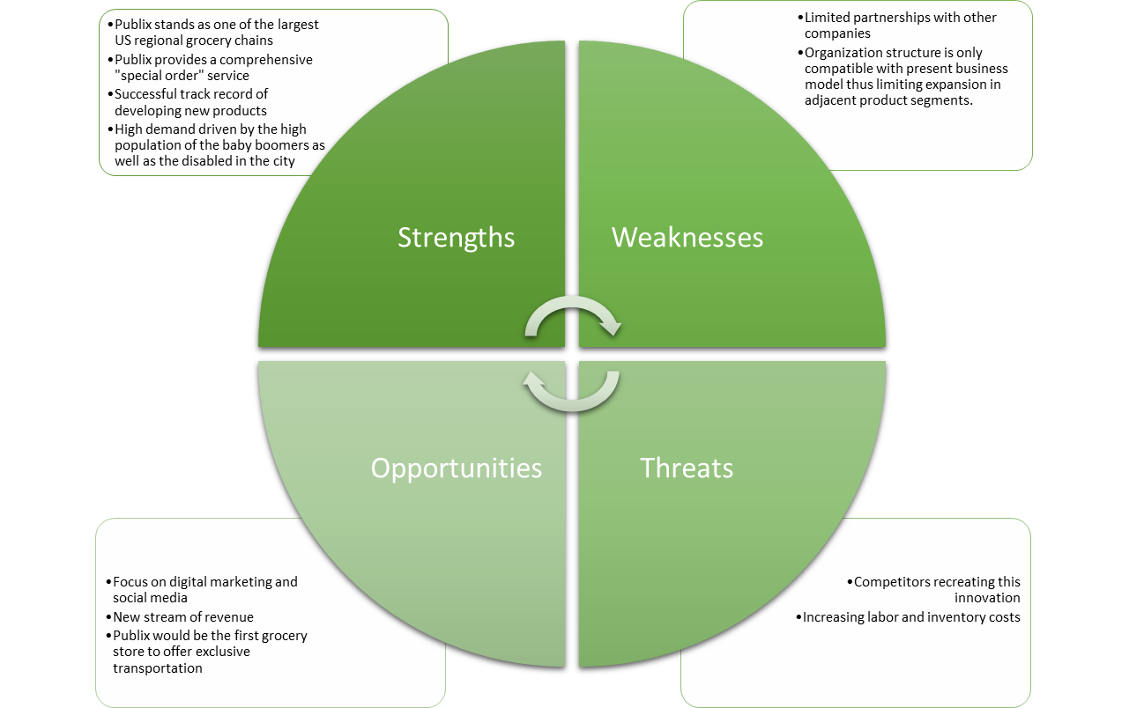

Services
The transportation service will cater to the elderly and disabled in the society to meet their needs in the food retail. This transport service if proposed to increase demand of the company’s product as well as increase profits for the company.

Service life cycle
- Exploration stage
At this stage, the business does not expect to get a large number of customers as the population will not have become aware of the added service in the company. At this stage, there is need to create more awareness to the public about the new service.
- Involvement stage
At this stage, all the departments in the organizations are required to take part in creating awareness of the new service in the company with a sole goal to increase awareness about the service and increase demand of the service.
- Development stage
At this stage, the stakeholders can be involved to take part in marketing of the service. By this stage, the company will have a good number of transportation service customers and the number will be increasing due to the marketing strategies already laid.
- Consolidation stage
At this stage, the number of sales will be enough to meet the cost incurred by the service and the company will be making profit. Strategies to increase and maintain the number of customers would also be discussed to meet customers’ satisfaction.
- Stagnation stage
At this stage, the number of demands for customers will not be increasing nor decreasing. The public will already be aware of the new service. Publix will need to analyze strategies to increase demand as well as promotion of return visits for purchase.
- Decline or rejuvenation stage
At this stage, the demand for transport service in the company would increase when rebranding of the service are done, or decline if no strategies are put into practice to increase the purchase of the service.

Below is a simplified corporate structure of Publix Company,
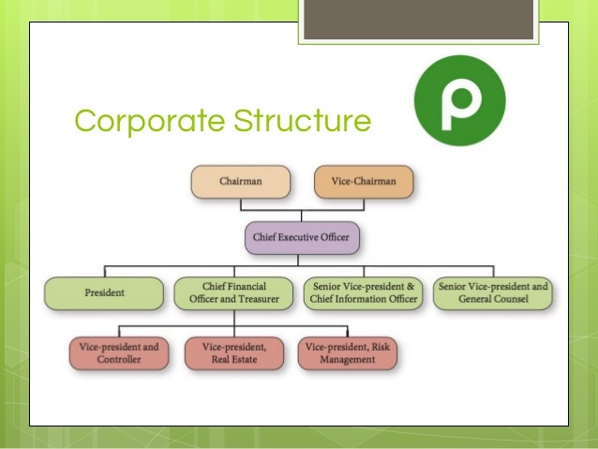
(Publix case 6 PPT, 2016).
The key managers in Publix Company are:
- Chairman- William E Crenshar, he is the grandson to George Jenkins. He has worker for Publix for 42 years, and served as CEO from 2008 to 2016 (Valverde M, 2016). He began his career as a clerk in the company.
- Chief executive Officer- Randall Todd Jones, he has worked for Publix for 36 years and started his career as a clerk. He served as the president of Publix since 2008 (Arnold K, 2016). He is the first non-family member to lead Publix.
- Senior vice president- Allison M Smith, she joined Publix in 1995 in a part time role. She has a PHD in industrial/organizational psychology, and she was promoted to give strategic oversight of customer care and social media, media and community relations and Human resource (Publix supermarket 2017)
- Executive Vice President- David R Phillips, started his career as an internal auditor in 1984. He is also the chief financial manager since 1999.
- Vice president (real estate assets) - William Raybern, started working with Publix in 1993 as a business analyst. In 2017 he was promoted to the Vice president position ( Publix supermarket 2017)
Under plans to attract, develop and maintain Publix focuses on employees and invests in them for quality productivity and organization economic gain. Each employees is surveyed each year for feedback in compensation packages reward, policies and leadership (Publix super market 2017). Employees also take educational programs to help enhance their skills and knowledge and achieve the business objectives of Publix. Employees receive an 8.5% bonus in terms of Publix stock for 1000 work hours done per year. Also each associate has a chance to become a manager (Solomon B, 2013)
Retirement and financial benefits in Publix are:
- Profit sharing
- 401(k) plan
- Defined contribution plan
- Health and insurance benefits
Marketing plan
Proper market research- Publix will use its competent marketing as well as sales team to market its new service. The marketing team will conduct a primary as well as a secondary research in order to determine the tastes as well as the preferences of its customers in order to advice the responsible transport department. The primary research will entail collecting appropriate data from its customers through interviews and online questionnaires. On the other hand, the secondary research will entail the marketing team conducting a review of available literature on marketing.
Publix Company faces stiff competition from Albertson Company which was founded some years later after Publix. It offers the same products as Publix. There are others such as Kroger, sprout farmers and many others. The graph below show the comparison of net incomes of the Publix company competitors
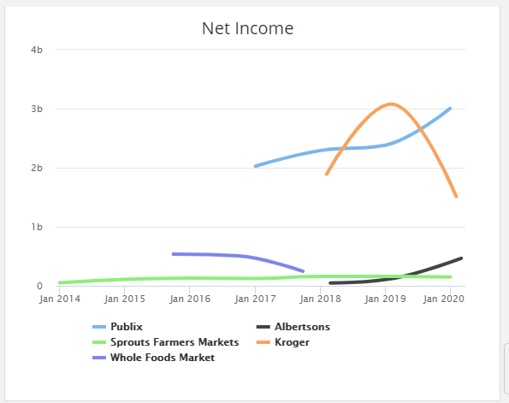
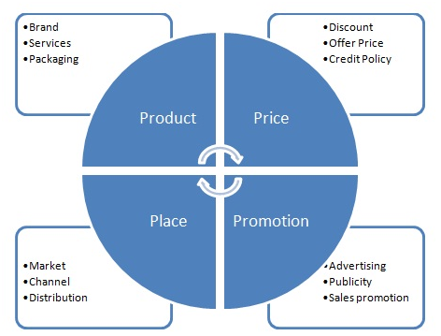
McCarthy (1960).
Product
This is what the business organization is selling. In this case Publix is offering retain and plans are underway for transport service provision. Product or service uniqueness persuades customers’ decision to purchase a certain product or a service. Publix preferred transport service is unique in that there has not been any other retail supermarket offering transport services to elderly and disabled in the society.
Price
Price is the amount changed for the provision of service or purchase of a product. The best price selection should be one that is considerate to customers and at the same time one which maintains economic sustainability of the business.
Promotion
These are the marketing strategies used by the organization and how effective the marketing strategies are in increasing demand for products and services. Publix Company has a good package that is consumer friendly as they have an added advantage of transport services to the elderly and disabled in the society.
Place
Location of a business is a major factor that should be considered as it has impact on purchase decision. A good location should be one that is easily accessible by local means of transport. Florida being a densely populated areas Publix company is assured of continuous inflow of sales and demand of the transport services due to the high number the elderly and disabled.
Publix like any other operating business has various strengths and weaknesses that have impact on the customers’ satisfaction of their needs. To focus on strengths the employees consideration and priorities given to them motivates them to deliver quality service to the customers. This make the company to be the top ranked in terms of quality service provision. Many customers are very sensitive in terms of quality service provision as they are aware of what they need from a particular organization. In terms of weaknesses, one of the main weaknesses in the Publix Company is that they spend a lot in attrition of workforce for better service delivery. Publix takes initiatives to educating of its employees and also profit sharing strategies which are only unique to this organization as their competitors doesn’t have such strategies. The company structure makes it complicated to handle a small issue on the ground as each person is answerable to a higher personnel in the organization structure. To handle a small issue on ground it spends a lot of time as the recommendation has to come from CEO down to the clerk.
Publix Company uses 4 types of distribution channels of its products and services to customers. One of them is direct channel which is the purchase of the products direct from the producer to the consumer. The 2nd one is retail channel where customers purchase their preferred goods and services from retails. The 3rd channel of distribution is wholesale channel where retailers source purchase their products from Publix to sell to customers. The last one is Agent channel when there are agents or brokers who purchase the goods and in place of the final consumer.
Operations plan
Transport service department will develop a website for online booking of the transport service in the Florida city for elderly and disabled
The preferred customer will be required to do online booking and the service delivered within the next 45 minutes from delivery.
The transport services will provide service men who will help the customer in purchase of the goods in the business upon arrival.
Drivers will be required to key in the website as ‘booked’ after the customer books the service for ease of the management to identify how many vehicles are available at a particular time.
At later stages the company will employ more employees to cater for the increasing number of customers if need arises.
The website will have a platform for customers to ports their after service comments for quality service provision as well as meeting the customers’ preferences.

Financial plan
Publix Company will need a total of approximately $ 150,000 to start its transport service operation. That will cover the startup materials, the hiring process, and marketing. $100,000 will be sourced from their account while the rest $50,000 will be acquired as a loan from a local bank.
The company will purchase two vehicles at the first stage and another two after a period of about 4 months checking the progress. The cost of a wheelchair accessible van is about $40,000. So, it will cost $80,000 for the first two vehicles. Some drivers will also utilize their own vehicles for transportation. Insurance will cost about $200-250 per vehicle. To save money, Publix can require rideshare insurance for every delivery driver that uses their own vehicle.
For the hiring process, Publix can hire two full time delivery drivers to drive their accessibility vans. Every other driver can be an independent contractor, so Publix can cut costs.
The subscription will be $29.95 monthly with a two time per week limit for roundtrip rides. There will also be a day pass option for one ride only that will cost $15 for a roundtrip. That will be available for customers who don’t want to pay a subscription or don’t frequent the grocery store that often.
A vehicle will carry a minimum of 4 passengers at a go to minimize the cost as well maximizing the profit to the company.
Action plan
The transport department manager will be required to forward all the activities run by the department on weekly basis.
Analysis on the cost incurred will be done monthly, along with the profits, to determine the impact of the transport service introduction to the business.
Vehicle mileage should be recorded before and after taking any journey during the operation.

Conclusion
Today’s service industry has seen gradual changes in that today customers are aware of what they want and they expect to get quality service from a service provider. Due to this, there is a need for the service provider to do enough market research on the customers’ changing trends in order to satisfy customer needs. For the case of Publix food retailing business, they have gained competitive edge by introducing a supportive service to cater to the elderly and disabled in the society. They are being considerate to the high population of elderly and disabled in Jacksonville and through this, will get more profits from the increased demand of their goods.

Recommendation

- The Publix Company should partner with the transport service providers in Jacksonville to avoid putting a lot of capital in purchase of assets.
- Publix Company should hire independent contractors to lower the hiring costs. If they are an independent contractor, they are required to supply their own vehicle, vehicle rideshare insurance, and gasoline.
- Publix could expand this service to their other locations with a high percentage of elderly and disabled customers in the area.

References
65 and Older Population Grows Rapidly as Baby Boomers Age. The United States Census Bureau. (2020). Retrieved 6 November 2020, from https://www.census.gov/newsroom/press-releases/2020/65-older-population-grows.html.
About Publix, Publix.com retrieved July 28, 2017
Ameratunga, S., Spray, J., Anderson, A., Wiles, J., Witten, K., & Ofanoa, M. et al. (2019). Inclusive Streetscapes: Disabled People and Older Citizens Charting a Roadmap to Equity. Journal of Transport & Health, 14, 100729. https://doi.org/10.1016/j.jth.2019.100729
Arnold K (2016) Publix CEO brings energy to new role. Orlando sentinel, January 23.
Bouffard, K. (2020). Publix reports more financial success. Retrieved 6 November 2020, from https://www.theledger.com/news/20200302/publix-reports-more-financial-success.
Connolly, J. (2019). Finding Transportation Services for seniors. Agingcare.com. Retrieved 6 November 2020, from https://www.agingcare.com/articles/finding-transportation-services-for-seniors-104572.htm.
Disability & Health U.S. State Profile Data: Florida | CDC. Centers for Disease Control and Prevention. (2020). Retrieved 6 November 2020, from https://www.cdc.gov/ncbddd/disabilityandhealth/impacts/florida.html.
Disabled population U.S. by state 2018 | Statista. Statista. (2019). Retrieved 6 November 2020, from https://www.statista.com/statistics/794278/disabled-population-us-by-state/.
Facts and figures. Publix supermarket retrieved March 7, 2018.
Gardner, M. (2020). Council Post: What Are The Implications Of An Aging Population On The Mobility Industry? Forbes. Retrieved 6 November 2020, from https://www.forbes.com/sites/forbesbusinessdevelopmentcouncil/2020/04/30/what-are-the-implications-of-an-aging-population-on-the-mobility-industry/?sh=482a5b393ebd.
Galarza Carlos Publix Sabor doesn’t scare off local competition, Orlando Business Journal. 2006
Gleckman, H. (2019). Why Can't We Expand Access To Transportation For Older Adults? Forbes. Retrieved 6 November 2020, from https://www.forbes.com/sites/howardgleckman/2019/02/18/why-cant-we-expand-access-to-transportation-for-older-adults/?sh=75e2fc6e5c84.
Lee, E., Same, A., McNamara, B., & Rosenwax, L. (2017). An Accessible and Affordable Transport Intervention for Older People Living in the Community. Home Health Care Management & Practice, 30(2), 54-60. https://doi.org/10.1177/1084822317744759
McCarthy (1960). Basic marketing a management approach.
Older Adults & Transportation. National Aging and Disability Transportation Center. (2020). Retrieved 6 November 2020, from https://www.nadtc.org/about/transportation-aging-disability/unique-issues-related-to-older-adults-and-transportation/.
Publix Sabor. Publix asset Management Company. July 5 2016.
Publix supermarket Inc. (2017). Publix announces officer promotions. From
https//corporate.publix.com./about-Publix/news room/ new-release/Publix-announces-officer-promotions, accessed November 19 2017.
Publix supermarket Inc. (2017). Why Publix: benefits. From
https//corporate.publix.com/careers/why-Publix/benefits, accessed November 22, 2017
Senior population of the U.S. by state 2019 | Statista. Statista. (2020). Retrieved 6 November 2020, from https://www.statista.com/statistics/736211/senior-population-of-the-us-by-state/.
Shaver, K. (2018). Survey: People with disabilities and the elderly need more help finding transportation services. Retrieved 6 November 2020, from https://www.washingtonpost.com/transportation/2018/12/07/survey-people-with-disabilities-elderly-need-more-help-finding-transportation-services/.
Smialek, J., Casselman, & Friedman, G. (2020). Workers Face Permanent Job Losses as the Virus Persists. Nytimes.com. Retrieved 6 November 2020, from https://www.nytimes.com/2020/10/03/business/economy/coronavirus-permanent-job-losses.html.
Span, P. (2019). Older People Need Rides. Why Aren’t They Using Uber and Lyft? (Published 2019). Nytimes.com. Retrieved 6 November 2020, from https://www.nytimes.com/2019/08/16/health/uber-lyft-elderly.html.
Su, F., & Bell, M. (2010). Transport for older people: Characteristics and solutions. Research in Transportation Economics, 25(1), 46-55. https://doi.org/10.1016/j.retrec.2009.08.006
Turner, J. (2020). Florida Unemployment Rate At 7.6 Percent As Struggles Continue. Miami.cbslocal.com. Retrieved 6 November 2020, from https://miami.cbslocal.com/2020/10/16/florida-unemployment-rate-struggles-continue/.
Williams, D. (2020). Some grocery stores are offering 'elderly hours' to help protect older shoppers. CNN. Retrieved 6 November 2020, from https://edition.cnn.com/2020/03/16/business/coronavirus-grocery-elder-hours-trnd/index.html
Valverde M (2016), Publix CEO retiring after 42 years of service. Sun-Sentinel April 28: Business DI

